Building a sales kit that works

by Julia King Tamang, LERN’s Senior
Consultant for Contract Training
Having a point-of-sales kit is helpful. The key for success at minimum cost is flexibility. A simple folio with removable inserts is a great way to go. LERN recommends you allocate up to 5% of your contract programs budget for promotions, so you can use some of those dollars here.
A good sales kit includes some or all of the following:
A simple card-stock weight “pee-chee” style portfolio, printed in two or more colors on an elegant paper will do. One color is an option, of course, but highlighting information is easier if you have more than one color to work with.
Remember, this kit is a sales piece. Its function is to be the prospective client’s introduction to who you are and what you do. It should have your Unique Selling Proposition on it at least once. It should focus on what you do and the benefit of those services to the prospective client.
The inside should allow die cuts for the insertion of a business card. All of the contact information for your institution should be printed on the folder as well, in the event that the business card is removed.
The filler pieces — more in-depth descriptions of classes and services, faculty information, articles and so on — can be photocopied onto good quality stock and inserted. This will allow you to update on a regular basis without having to reprint the more costly folder that contains these pieces.
Using the filler pieces allows you to build custom kits for each prospect. You can carry some generically- filled ones for cold calls and build ones specifically suited to an individual or a company before you meet for the informational interview.
The general design of kit should follow two rules: the 3-30-3 rule and the principle of AIDA.
The 3-30-3 Rule
The 3-30-3 rule is a level of readership guideline. It tells you that you have three seconds to capture the reader’s attention in a printed piece. Three seconds isn’t much time, so the message needs to be exceptionally clear: Who is this piece from and who is it for?
Anything you can do to help the reader quickly determine whether they should read on is useful here. This is the first level of readership. The reader asks the question, “Is this piece relevant to me, at this time?” Things that can give quick clues are:
• the logo of your institution  • your USP (Unique Selling Proposition)  • the name of your institution and department  • a photo or the colors of your institution  • the look and feel of quality paper and printing  • a provocative statement, question or promise  Everything from the typography to the paper choices you make sends a message in these critical first three seconds. If the reader is convinced in three seconds that this piece might have relevance, they will read on — typically to the inside panels, in the case of a sales kit. This next level of readership, a 30-or-so-second scan, allows the reader to answer the question, “What’s in here for me?” | 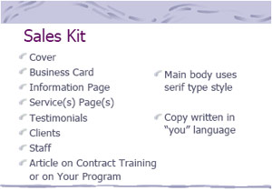
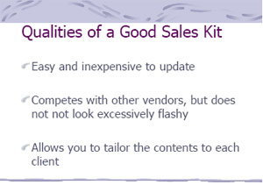 | If you are able to help the reader ascertain for certain that the material IS relevant for them — that it’s a service they need or may need, for example, you generally have about three more minutes to prove that you are the correct provider, that you can deliver on the claims that you made, and so on. At this point, the third level of readership, you can also move the reader to action.  AIDA  The AIDA principle is the journalistic rule that says that the four stages of reader engagement are: attention, interest, desire and action.

Each of these four stages is necessary to get the reader to engage fully in a printed piece and to act on the information.
Attention
Readers are attracted by capturing their attention. In a sea of information, what will make your piece
stand out as deserving to be read? The most effective way is to appeal to the reader’s self interest. Ask a question, make a claim, offer a benefit of value to the reader.
Interest
Once you’ve captured the reader’s attention, build interest. Do this by showing benefits available to the reader. If you can do this in easy-to-read lists that employ bold-facing or bullets, it will help. Remember, the reader will likely be skimming, looking for evidence that the contents make sense for them.
Desire
If you’ve ignited the reader’s interest, now build on that interest to create a desire to look further and to experience a taste of a relationship with you. Prove that you can do what you say with client lists and success stories or lists of potential benefits. Build credibility and show people why they should get these services from you.
Action
Finally, even a convinced client needs a call to action. How can they contact you? What do they do next? Can they fax, or visit for more information? Will you send them valuable information? Should they register or what? Be clear, and offer as many options for “next steps” as you can. By building all four steps of engagement
— attention, interest, desire and action
— you can create a sales kit that sells
before you arrive and after you leave. A good sales kit can help compensate for a fledgling sales skills set and will help you have confidence and stay more organized in your presentations.
Working with a Designer to Create a Sales Kit
If you will work with a designer to produce your sales kit, here are a few questions that you should be ready to answer.
These questions will help you communicate to the designer what you want and need. Do your homework. Think through the answers before you meet and take samples of pieces you like.
- What can you tell the designers about your business?
- What is the purpose of this publication?
- Who is your audience for this piece?
- Who is your competition?
- What do you know about them?
- What is the role of this piece in your overall strategy?
- What are the specifications of this project? (number of pieces to be printed, one color or two, and so on)
- What’s the image you’d like to project?
- Does your institution have a style sheet that the designer should follow?
- Do you have any graphics or photos that you want the designer to include?
- Who will write the copy?
- Will the copy and the art come to the designers in hard-copy or on disk? If it comes on disk, what can you tell them about your computer system?
- What’s your budget?
- What’s your time line?
- Do you have preferred vendors you’d like the designers to work with for printing, photography and so on?
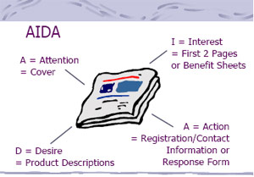

© LERN – This report is not to be reproduced outside the LERN member organization without written permission.

