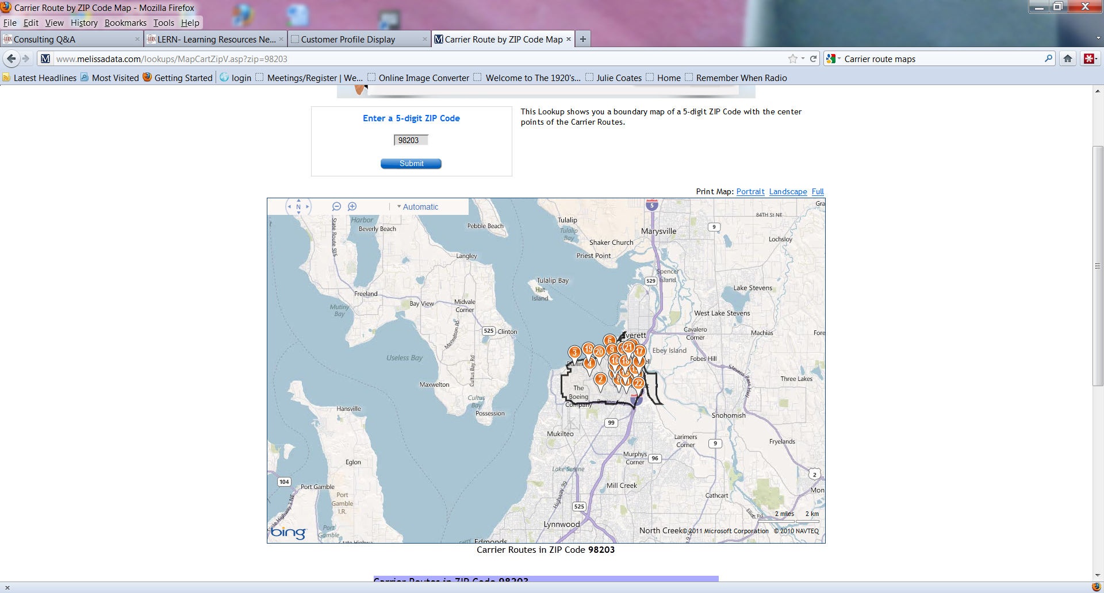
This map is available free through Melissadata. There are also links for demographics by zip code, etc on the landing page from the link in the email I sent you. The map can be expanded so that you can see the area within the zip code for each carrier route.

