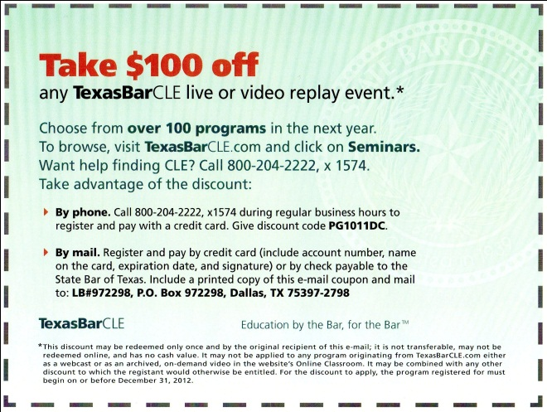
Award Winner
Discounts Work for Associations
For best marketing, Continuing Legal Education, State Bar of Texas, Austin, Texas, Pamela Gilley accepting. Especially in these tough economic times, discounts work. Everyone should be offering something for a discount. This program offered a $100 discount on any course or event and then tested two different email subject lines with customers who had not taken a course in the past three years. The email brought in $16,000 in two days, income they would not otherwise have had. You should be offering a discount on something. Promote it with email. Reap the rewards. In these tough times, discounts work. Here’s what they say:
This marketing effort was aimed at Texas-licensed attorneys who had not registered for a one of our live or video course in the past three years. Two separate eblasts were sent containing the image of a coupon. (A plain text version of each simply included the text of the coupon.) The non-transferable coupon offered the recipient $100 off any live or video event in the next year and included instructions for redeeming it (see attachment).
The first eblast issued on January 27, 2010, to 21,687 recipients and resulted in a 37% open rate. The subject line was "Take $100 off CLE!" ("CLE" is a well-known acronym among legal professionals for "continuing legal education.") The second eblast went out April 13, 2010, to 21,558 recipients and had a 39% open rate. The subject line was "Take $100 Off Your CLE."
To date, there have been 53 registrations utilizing the coupon, for a total revenue of $16,045.

We deem this marketing effort a resounding success for these reasons:
- We believe it resulted in registrations that we otherwise would not have gotten.
- The discount, while substantial, still enabled us to realize a profit on each registration.
- The offer resulted in new customers as well as returning ones.
- The eblasts were generated in-house, essentially costing us nothing.
We will definitely repeat this effort in the future.

