Section IX
Pricing

Listing Your Prices
How we list our prices does have an effect on attendance. Here are some guidelines:
1. Do not put decimals and zeros after the price. For
example, do NOT list a price as $195.00. List it as $195.
2. Avoid round numbers. In an informal survey of asso-
ciation sponsored seminars and conferences, I found about
half used round numbers, such as $50, $100, or $200, as
the fee. There are two things that go on with round num-
bers. One, you are more apt to hit a price break if you list
your prices in round numbers. And two, people just don’t
like to buy things priced in round numbers.
People like to buy things whose prices end in 5 and 9, say pricing experts. Instead of listing your price as $50, list it as $45, $49 or $59.
3. Don’t highlight, and don’t hide, your price. Generally,
price is not a reason for a person to attend your event. So
highlighting your fee is not recommended. The exception is
if your event has a lot of competition and you are offering it
at an extremely low price as compared to the competition.
Most meetings sponsors are not in this position.
On the other hand, you should not hide your price either. It should be located at the back of your brochure or publicity, but people should be able to find the price easily. To make it difficult to find is to provide the impression you are trying to conceal it.

Playing Price Breaks
A strange phenomenon in consumer purchasing is
called the “price break,” the point at which a person
says the price is too high. Different people have different
price breaks, and of course there are separate price breaks
of various kinds of seminars and conferences.
Some price breaks are $25, $50, $100, $200, $500 and
$1,000. The larger the numbers, the less often there is a
price break. For prices under $100, $25 is a price break and
so is $50. But a fee of $225 is probably not a price break in
the $200-$300 price range, while $250 might be. And

♦ CPP Readings IX-1

$550 is probably not a price break in the over $500 price
range.
We are all influenced by price breaks. The fee of $100
is a price break for some of us. For my staff, for example,
$100 is a price break. If there is a seminar for $98 and a
staff person wants to attend, I would approve it. I usually
say, “Go, you need this, take some notes, have a good
time.” But the same seminar priced at $102, and my reac-
tion is, “We’re not IBM. We don’t have that kind of money
to throw around.”

Price As Image
We also have a concept of people attending events at
various price levels. While it is fine to send support staff,
for instance, to seminars priced at under $100, administra-
tors and executives are less likely to attend. We just don’t
feel that there can be that much in it to learn at that price.
But if the same event, the same speaker is priced at $195,
we will attend.
This has been shown to be the case with computer semi-
nars. Price the computer seminar at $45 and certain types
of people will attend. Take the same seminar with the same
speaker and description, and price it at $195 and other
types of people will attend. And they both will evaluate
the seminar without regard to price, but on the merits of
the content.
So we have an image of seminars and conferences, and the price of a particular event is part of our image of it. Association expert Jim Lowe said that we are what we are perceived to be. That is certainly true in terms of prices. We convey an image in our pricing.
A very low price is going to indicate a lack of quality to
some people, while most of us assume a high priced event is
of high quality. While this is not always true, it is the case in
enough instances that most of us relate price to quality.
Underpricing
Most of us are concerned about raising prices so high
that we turn attendees away. In fact, the most common
mistake in pricing seminars and conferences, according to

IX-2 CPP Readings ♦

seminar guru Anver Suleiman, is underpricing — charging too little.
The concepts of price breaks and price as image means that some of us will not spend over a certain amount to attend an event. But it also means that we will not spend less than a certain amount to attend an event.
There is an actual perfect case study of underpricing
from a town in British Columbia, told to me by one of the
people involved during a seminar I conducted near Victoria.
In this town, three different organizations contracted
with the same speaker to give the same seminar, with each
organization unaware that the speaker was contracted with
either of the other agencies. One priced the seminar at $35.
Another priced it at $95. And the third priced it at $135.
The title, speaker, and brochure copy were identical.
The program that offered the seminar at $35 had to can-
cel for lack of enrollments. The program that offered it at
$95 was three-quarters full. And the program that offered
the seminar at $135 had a waiting list and had to turn
people away.
It is not only possible to underprice, it happens all the time and it happens more frequently than overpricing. And underpricing has the same negative effect on attendance as overpricing — it turns people away.

The Impact of Pricing On Attendance
It is commonly assumed that an increase in price is accompanied by a decrease in attendance. That is not the case in the majority of cases.
On the next page is a chart of the effect of price on
attendance. There is a rough correlation between atten-
dance and pricing, but it is not what is commonly as-
sumed. On the chart, we start with zero dollars on our
price and we increase the price along the horizontal line.
The resulting impact on attendance and on income is
shown on the vertical line. The attendance curve that re-
sults is one in which attendance actually increases for
awhile when we raise prices. Income also increases with
the price increase and attendance increases. After a cer-

♦ CPP Readings IX-3

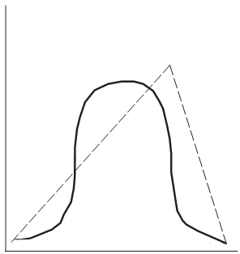

Increase in Price

tain point attendance does not increase when we raise
the price, but it does not decrease either. Instead it re-
mains stable. Income, however, continues to grow as a
result of the price increase and stabilized attendance. If
we continue to raise the price, eventually the attendance
will drop but the income will continue to grow or remain
stable. Finally, if we increase the price high enough, it
leads to a sharp decrease in attendance and thus a de-
crease in income as well. That stage is the one which we
all fear as meetings sponsors, but one that happens infre-
quently. Instead, most of us are somewhere else on the
chart. And that means that increasing prices would be
beneficial for most of us, rather than detrimental.

The Impact of Pricing Changes
If pricing affects attendance, there is also an impact of
pricing changes on the attendance needed to make budget.
Charles W. Kyd, an accounting consultant and author of Financial Modeling Using Lotus 1-2-3 (published by Osborne McGraw-Hill), wrote a revealing article in the April 1987 issue of Inc. magazine showing the relationship of a price change to attendance.

IX-4 CPP Readings ♦
Number of dollars or attendees
Dollar Income
Attendance

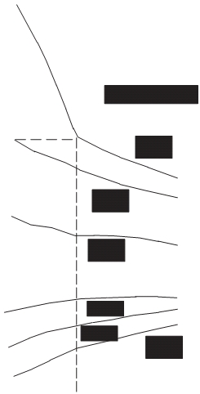

An adaptation of his chart is given below. Kyd used
fishing lures as his manufacturing example. He also as-
sumed that production costs remain the same as volume
increases or decreases, which in the seminar and confer-
ence business is not always true. But the example is strik-
ing enough that it gives us a good deal to think about.
Translating from products to attendance, Kyd’s chart
shows that a small price increase allows us to have a de-
crease in attendance and actually arrive at the same point
financially as before the price hike. On the other hand, a
small decrease in price would have to be accompanied by
a very large increase in attendance for us to be able to
have the same financial outcome as before the price change.

Here is an adaptation of his chart.
Percentage Changes in
Participation Required to

♦ CPP Readings
+100%
+90%
+80%
+70%
+60%
+50%
+40%
+30%
+20%
+10%
0%
-10%

-20%
○ ○
-30%

-40%
Maintain Operation Margin
in Dollars After Price
Change

Price Change

-15%

-10%

-5%

+5%
+10%
○ ○ ○ ○ ○ ○ +15%

30% 40% 50% 60% 70%

IX-5

Operating Margin Before Price Change
(Adapted from article and chart in April 1987 Inc. magazine.)
In the above chart, the horizontal axis is your Operat-
ing Margin, the profit you wish to maintain as a percent-
age of income. The vertical axis is the change in
attendance needed to maintain your Operating Margin
for the meeting.
To use the chart, start at the bottom with a given Op-
erating Margin. Move up to the line with the Price Change
being contemplated. Then follow that Price Change line
over to the Change in Attendance percentage to find out
what kind of change in attendance is needed to maintain
the Operating Margin.
For example, assume we have an Operating Margin for
our seminars of 45%. If we wanted to decrease our price
for seminars by 15%, we would need to increase our atten-
dance by a whopping 50% in order to maintain the same
Operating Margin.
On the other hand, if we raised our seminar fees by
15%, we could experience a 25% decline in attendance and
still maintain our Operating Margin. Of course, if atten-
dance did not decline that much, stayed the same, or in-
creased, our profits would be that much greater. So a price
decrease entails the expectation of a great increase in at-
tendance, while a price increase can withstand a fair
amount of attendance decline and still be in our financial
best interest.

IX-6 CPP Readings ♦

Other Reasons To Increase Your Price
There are other reasons to increase the price of your seminars and conferences.
1. Your costs will continue to go up. Inflation, paper prices, hotel costs, speaker fees, food costs, and other expenses will all continue to rise. A price increase is needed just to keep pace with your expenses.
2. Increased income allows you to have a higher quality pro-
gram. With increased income, you are able to improve the
quality of your events. That may mean better speakers,
adding meal functions, holding a reception, or adding some
fine touches like improved name tags, after luncheon mints,
a bouquet of flowers, or live music for a reception.
3. In a recession, seminar attendance drops. This is a given
in the industry. And seminar experts recommend raising
seminar prices in a recession. They say that there are two
kinds of seminar participants - those who want to attend,
and those who have to attend. You are likely to keep those
who have to attend, and will lose some or all of those who
want to attend. The price increase is one of the best ways
to maintain financial stability in the face of declining at-
tendance.
4. Participant satisfaction is more important than a few bucks. In your eyes, the cost of your meeting is the registration fee. But in the eyes of your attendees, the cost of your meeting also includes travel, meals, overnight accommodations, lost work time, and perhaps some time getting over jet lag upon returning.
Thus, from the participant’s point of view, satisfaction
with your event is more important than concern over a
small price increase. For instance, if a participant is spend-
ing $750 in plane fare and hotel to get to a conference, a
conference fee increase of $25 will be welcome if that in-
crease can provide better meeting facilities, a tour, better
speaker, or convenient access to local sights.

♦ CPP Readings IX-7

How Much To Increase Prices
How much can you increase prices without doing some
prior survey or repackaging of your event? The following
are guidelines for seminars and conferences priced at $100
or more.

Price Increase What To Do

0-14% Just do it (unless you go over
a price break)

15-24% Test the increased price or do
a survey first.

25%-49% Add new features to your
event to justify the increase.

50% and up Make it a “new” event and/
or conduct a public relations
effort.

If you are charging $100 or more for a seminar or con-
ference and want to increase your price less than 15%, just
do it. The only situation in which you might want to re-
consider is if you are going over a significant price break.
For instance, if you think $200 is a price break for your
audience and your current price is $195, going to $205
may be something you would want to think about or do a
survey or test. But if you are at $175 and thinking about
going to $195, just do it.
If you are going to raise your price by 25% to 50%, you
should add some new features to your seminar or confer-
ence. You could add a meal, have a speaker of a better
perceived quality than in previous events, add another half
day to the event, or any number of new features.
If you are contemplating raising your fees by 50% or more,
I would not do it without promoting it as a “new” seminar
or conference —“all new,” “revised,” or whatever. This
might include a format change or content change.

You might also consider a positive public relations

IX-8 CPP Readings ♦

effort with your audience to promote this “new event.”
Be sure to emphasize the positive and not to apologize
for raising prices. In fact, it would be best not even to
mention the increased cost, only the increased benefits.

When To Lower Prices
There are a few instances when it might be to your advantage to lower your fees. They include:
1. To get off a price break. For example, if your event is
priced at $200 you might benefit if you think you would
significantly increase attendance by lowering it to $195.
On the other hand, you might also consider raising it to
$225 since people are already willing to pay for your event.
2. To reach another type of audience. If the type of participant is changing, or you want to reach a different audience with a lower price break, a lower price would accompany that effort.
3. If the economics dictate. In some cases, the econom-
ics of your audience’s situation necessitate a price de-
crease. But, before implementing a decrease based on
necessity, be sure that the necessity is a reality, not just
an opinion.
4. If your expenses decline significantly. If you can cut
costs dramatically AND feel that a price decrease would
increase attendance, then a decrease might be contemplated.

Pricing Strategies
Your marketing strategy and pricing strategy go hand in hand. Different pricing strategies should be employed depending on your marketing effort. Here are four different pricing strategies, each developed in conjunction with a specific marketing strategy.
Segment the market. You may be trying to reach more
than one type of person with your seminar or conference.
A different approach is to develop an event for only one
segment. For example, if you sponsor seminars for the le-
gal profession, you could try to get lawyers, paraprofes-
sionals, and legal secretaries all to come to one seminar.

♦ CPP Readings IX-9

A better strategy is to sponsor separate seminars for each
group. And each seminar would be priced differently.
Segmentation is not only by vertical organization in the
work setting. It involves separating people into different
groups based on any number of different characteristics.
Diversify. Another approach is to try to make your event more generic in nature, thereby broadening the audience. The pricing implications for this strategy would be to settle on a commonly accepted price for most people you are trying to reach.
Discounts for multiple registrations. One pricing strategy involves having discounts for multiple registrations. This is usually applicable to individuals registering for an event from the same organization or company.
Repeat participation. Some events are geared towards
gaining a high repeat audience. While this is typical of
conference attendees, it is also a good marketing strategy
for seminars, and building in a pricing structure to attract
repeat participation is usually financially beneficial for
meetings sponsors.
Diversifying your prices. Most meetings sponsors price their events in the same narrow range. For example, if you have an event priced at $75, it is a good bet that all of your events are priced from $50 to $100.
Diversifying your price is a way to reach other audi-
ences. To use the example above, some people are going to
want to attend an event priced at less than $75, and some
people will want to attend an event priced at much more.
So one pricing strategy is to see if you have something to
offer at a lower price, or at a higher price, and go after a
different kind of audience than the one you are now reach-
ing. One nice feature of this strategy is that you do not risk
losing your current audience, since you are developing a
different event at the higher or lower prices.

IX-10 CPP Readings ♦

Setting Course Prices
A common way to set course prices is to establish a
formula by which to set fees. The formula is easy to ad-
minister and is easy to justify to both learners and the
administration.
Typical formulas are based on the length of the course, the type of subject, or on the cost of paying the teacher. There are several problems with formula pricing:
1. It may not always cover your course costs, so that some courses may lose money;
2. It may not compare favorably with other programs’
prices, so that some of your courses might be underpriced
while others may be overpriced relative to the competi-
tion;
3. It may not be close to what people are willing to pay, so that some course may have too few enrollments because they are overpriced while some courses are underpriced and could be making more income. For example, a cake decorating class priced at $30 might be too high; while a computer class at $30 might be too low.
Thus, almost all successful programs prefer market pricing to formula pricing. Market pricing involves pricing each course separately based on three criteria:

1. The cost of producing the course;

2. What other programs are charging;

3. What people are willing to pay.
The best rationale for both learners and the adminis-
tration for the difference in course prices is the truth: the
higher priced courses subsidize the lower priced courses.

Your Costs and Teacher Costs
In determining your costs for producing the course, include the following:

—Total fees paid to the teacher

—Any costs associated with teacher wages, such as

♦ CPP Readings IX-11

a teacher’s health insurance or your social security contribution.

—Any other teacher expenses, such as travel.
—Materials you provide not paid for by the students, such as complimentary handouts or production costs for overhead transparencies.
—Equipment rental, such as a slide projector. —Any classroom rental costs.
Do not include the following in your course costs: —Staff time.
—Teacher training costs if that is in a separate budget. —Phone costs or correspondence.
—A portion of administrative office space or utilities. —Any other indirect costs or overhead.
After adding up your costs, do a break-even analysis for
your entire program, taking all your courses together.
The following are useful formulas in doing our breakeven analysis to determine a) the number of enrollments needed to break-even; b) the number of enrollments needed to break-even at a specified net profit; and c) the class fee needed to break-even.

The Competition
The primary concern of your program should be stay-
ing in touch with your audience and serving its needs,
including matching your audience’s preferences in pric-
ing. But you should also keep an eye on what other pro-
grams charge.
Some adjustments can be made on account of competition. In reality, however, there are only a few pricing strategies to address the competition:
1. Price just under the competition and stress your cheaper prices in promotion and in your marketing.

IX-12 CPP Readings ♦

2. Price higher than your competition and stress the
quality of your programming in your promotion and mar-
keting.
3. Price at the same level as the competition, and rely
on your program’s other factors, such as time, content,
location, and instructors, to differentiate your program
from others.

What People Will Pay
Least understood and receiving less attention than ei-
ther course costs or the competition’s prices is what people
are willing to pay. The worth of a class is really more a
function of how valuable it is to them, not how much it
costs you.
This criterion, given that your overall course costs are
covered, should be the primary consideration. Too few of
us are able to accurately judge what people are willing to
pay. There is much underpricing in class programs, or pric-
ing courses too low. There is occasionally overpricing. And
there is the problem of keeping prices current, taking into
account swings in public mood and attitude toward spend-
ing based on the state of the economy. For courses for the
community, this does not always mean lowering prices in
a recession and raising them in good times.
The best way to gauge what people are willing to pay is
to keep testing and analyzing your prices. As often as you
can, test a few price increases and/or decreases to deter-
mine if enrollments or overall income for that course go
up. And every session you can compare your enrollments
by the level of course fees. While the primary motivation
for enrolling in a course is and always will be the subject
matter, pricing does affect enrollments. Other consider-
ations aside, measuring how well your higher priced
courses are doing against your average priced courses and
your lower priced courses gives you more information for
tapping additional opportunities for both enrollments and
income. For example, if you find that enrollments for higher
priced courses are going up faster than your enrollments
overall, you might want to add more higher priced courses
to tap this new potential. And likewise, if you offer few
lower priced courses but they appear to do well, offering
more of them might tap into another market.

♦ CPP Readings IX-13

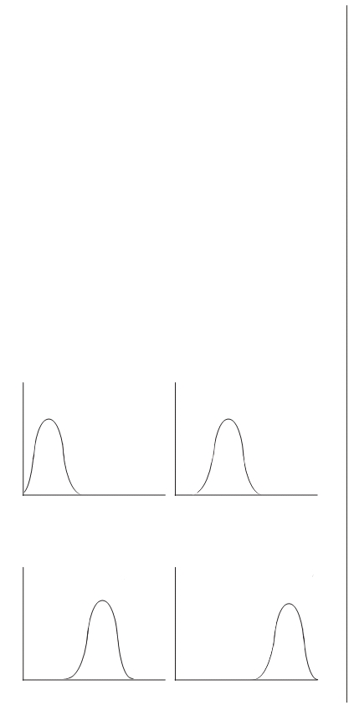

Course fees need to be updated at least once a year, based not only on increased costs or the competition, but more importantly on your changing market.
Market pricing of courses based on costs, the competi-
tion and what people are willing to pay is more difficult
and time consuming than applying a formula. But the im-
proved results will far outweigh the inconvenience.

Recommendations
1. Develop a budget with a 5% to 10% surplus in order to make your program financially self-sufficient and give you the opportunity for growth.
2. Determine your average course fee and use that figure in projecting income for each session.
3. One way to increase income is to offer courses that carry a higher price tag.

Low End Market Lower Middle Market

0 10 20 30 40 50 60 70 80 0 10 20 30 40 50 60 70 80

Upper Middle Market Upper Market

0 10 20 30 40 50 60 70 80 0 10 20 30 40 50 60 70 80

IX-14 CPP Readings ♦

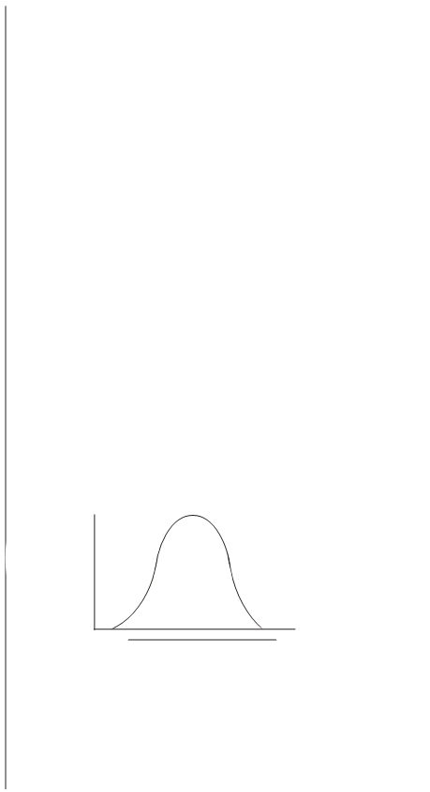

Analyzing Your Pricing
Just about every program of classes for adults con-
sciously or unconsciously prices its courses for a given
market. This is not only a matter of marketing and fi-
nance, but also of mission and purpose. In achieving
$100,000 in fee income, for example, some programs get
10,000 registrations at $10 each; some get 2,000 registra-
tions at $50 each; and some get 4,000 registrations at $25
each. The targeting of a primary price market is essential
and good practice. It defines your market, and tells your
target audience your program is geared toward them.
There are basically four price markets for a program of
courses:

Clustered Versus Diversified Pricing Strategies
Almost every program has half of its courses priced in
a narrow grouping that varies only by about 90%. But
what about the other half of courses? How are they
priced?
There are two different types of strategies for pricing
the rest of the courses. By far the majority of programs
price the other half of their courses around the middle,
so that there are not many courses priced at either end.
A graph of how most programs price is given below:

# or
%
of
courses

½  ¾

Price

In the above example, the prices are pretty well clustered around the middle. The actual prices may vary from the low end to the high end, but most programs cluster their prices around their price middle.

♦ CPP Readings IX-15

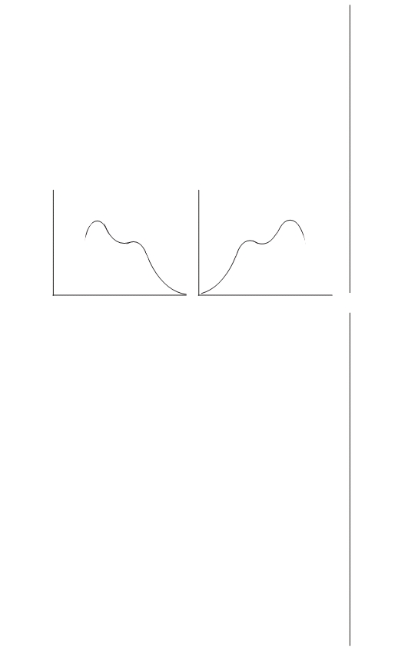

But there is another pricing strategy that we will call
diversified pricing. A Diversified Price Strategy takes aim
at a broader range in prices, and also tries to hit a sec-
ondary market either lower or higher than its primary
market.
Here is a graph of two approaches to diversified
pricing:

DIVERSIFIED PRICING

In the above two examples, both programs have extended their price range. They have more lower priced courses and more higher priced courses.
In addition, each has established a secondary price
market. In the example to the left, the program has
gone after a lower-middle price market, but in addition
has listed many courses in the upper-middle range to
attract an additional target audience. In the example to
the right, the program has done the reverse. The pro-
gram has gone after the upper-middle price market, but
in addition has listed many courses in the lower-middle
range to attract an additional target audience interested
in slightly lower course fees.
An excellent example of this kind of diversified pricing is the program at the Rochester Museum & Science Center in Rochester, NY.
The program has 50% of its courses in the $25-$40 range,
neither high nor low prices. But the Rochester Museum’s
effective range of prices goes from $16 to $60, a much
broader effective range than most programs. In addition to

IX-16 CPP Readings ♦

grouping many prices in the upper $20s, it also has a
substantial number of courses in upper $30s and $40s.
This is what is meant by the diversified pricing strategy:
1) extending the range of course prices; and 2) establishing a secondary grouping of course prices.
The effect of the secondary group of course prices may be either to try to reach another target audience, or to give your primary target audience another set of course options based on price. Either rationale is good marketing and good pricing. The use of Diversified Pricing by programs is likely to proliferate.

Recommendations
1. Chart your course prices to determine: a) your own effective range of prices; b) your middle 50% of courses; and c) graphically display them for analysis.
2. Look at your middle 50% of course prices. Re-evalu-
ate as to whether or not this is the area you want most of your prices to be in.
3. Look at your effective range of prices. We recom-
mend that your lowest price varies from the highest price
by $35 to $40. Do your prices vary that much? If not, can
you add some courses at the end to extend your price
range?
4. Consider establishing a secondary cluster of prices
either lower or higher than your primary area of prices.
This will either establish a secondary target audience or
offer your existing audience more of a choice in prices.

♦ CPP Readings IX-17

Study Questions for
Section IX: Pricing

1. List fees without: (p. IX-1)

2. Avoid using: (p. IX-1)

3. What is a price break? (p. IX-1)

4. Four recommendations on listing prices are: (p. IX-1)

5. Discuss the role of price in establishing an image of your program. (p. IX-2)

6. Formula pricing is: (p. IX-11)

IX-18 CPP Readings ♦

7. Market pricing is: (p. IX-11)

8. Why is market pricing better than formula pricing? (p. IX-11)

9. Market pricing involves pricing each course separately based on what three criteria: (p. IX-
11)

10. Three pricing strategies to address the competition are: (pp. IX-12, 13)

11. Least understood and receiving less attention: (p. IX-13)

12. What is clustered pricing? (p. IX-15)

13. What is diversified pricing? (pp. IX-15, 16)

14. Why is diversified pricing better than clustered pricing? (p. IX-16)

♦ CPP Readings IX-19

